**Stage 2**

**RULES:** USPSA Competition Rules, Latest Edition **COURSE DESIGNER:** RYAN CHRISTENSON

|  |  |
| --- | --- |
| **START POSITION: See written stage briefing.** | |
| **STAGE PROCEDURE**  See written stage briefing. | **SCORING**  **SCORING:** Comstock 30 rounds.  **TARGETS:** There are 14 cardboard targets and 2 steel poppers one of which activates the bobber which is visible at rest.  **SCORED HITS:** 2 Best hits per carboard will be scored, steel must fall to score.  **START-STOP:**  Audible - Last shot  **PENALTIES:** Per USPSA Competition Rules |

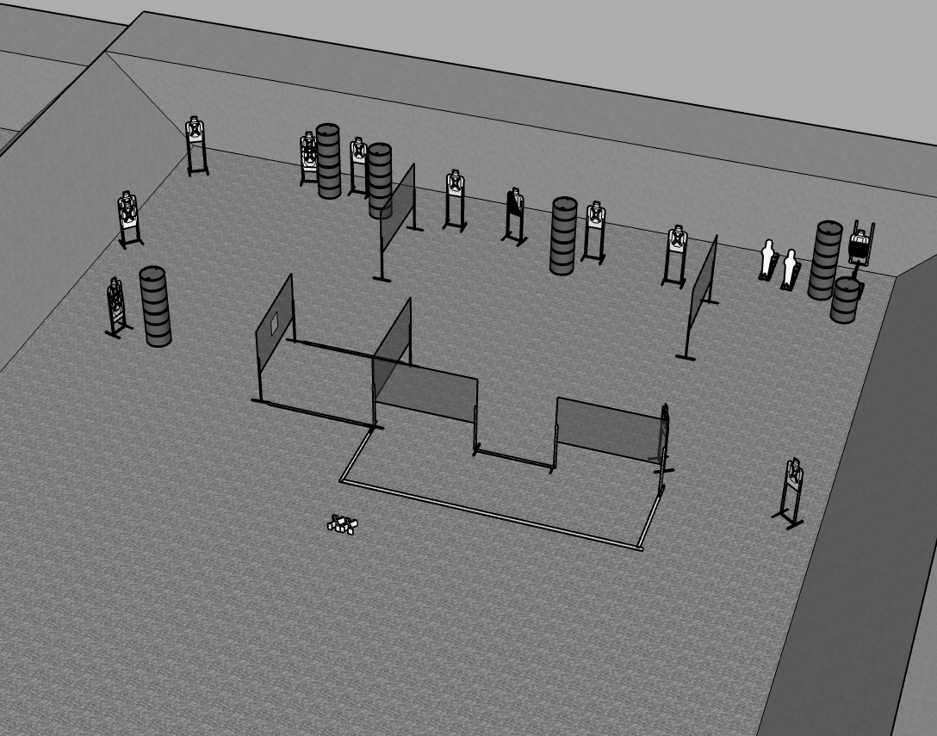

**Written Stage Briefing:**

**Stage 2 –** is a 30-round, 150 point, Comstock Long Course. There are 14 cardboard targets and 2 steel targets. The best 2 hits per cardboard target will be scored. The steel targets must fall to score. The bobber is visible at rest.

**Handgun start position** is standing both feet on XXs facing down range. The handgun is loaded and holstered.

**PCC start position** is standing with both feet on XXs facing down range. PCC is loaded, held in both hands with safety on, wrists above head with muzzle pointed downrange.

On the audible start signal, engage targets from within the shooting area.

**Setup Notes:**

Ensure Bobber target is not visible prior to activation.

Ensure far left target is only visible from left port.